**Glycemic Load Calculator with Image Detection**

Priyadarshan Dhabe, Bhargav Pawar, Nishant Bhat, S. Abhishek, Abhijit Gawai, ShyamKawale

Department of Information Technology, Vishwakarma Institute of Technology

***Abstract: Obesity, cardiovascular disease, and cancer are all life-threatening disorders that can be prevented with a healthy diet and balanced nutrition. High-calorie intake can be harmful and result in numerous diseases like obesity, diabetes, among others. As a result, it appears that tracking daily meal intake is critical for ordinary individuals who want to reduce weight or maintain a healthy weight. To accomplish this task, a mechanism is required that empowers the patients with a long-term solution and guide them to achieve constant and lasting changes to their dietary quality and calorie intake and although food packaging comes with nutrition (and calorie) labels, it is still not very convenient for people to reference. This system uses image classification algorithm i.e., yolo algorithm to determine the food item which the user wants to classify. This paper initially considers five different parameters namely dietary fiber, glycemic index, calories, protein, and fat. It includes continuous logging of these parameters with respect to the data provided initially by the user suggesting the necessary changes. Nutrition logging is also important in preventing diabetes, managing existing diabetes, and preventing, or at least slowing, the rate of development of diabetes complications. It is, therefore, important at all levels of diabetes prevention. The purpose of these guidelines is to raise awareness of favorable nutrition treatments among people with diabetes and health care providers. This allows monitoring the daily intake of the user.***

***Keywords: Image Classification, Food recognition, YOLOv4, GlycaemicIndex, Glycaemic Load, Flutter.***

# **Introduction**

The word "mindfulness" is definitely translated as "consciousness." It might be awareness of what we're eating, how we're eating, why we're eating, and when we're eating during this scenario. At dinnertime, many folks love snacking or grabbing "seconds." Unfortunately, this sort of behaviour can cause the daily calories to quickly add up. Continuous logging or keeping a track of what we are consuming on a day to day may be a behavioural technique which will help us put our habits in perspective. Our habits are an outsized a part of who we are and may determine whether or not we are successful. At times, our habits must change in order that we will accomplish our goals and grow as a private . thanks to the development in people’s standards of living and therefore the eating practices followed by the overall population, health risk rates are increasing at an alarming speed. People got to control their daily calorie intake and that they got to monitor what they consume during a day. Eating healthier food is that the most elementary method to avoid any life-threatening disease and maintain a healthy lifestyle. However, although food packaging accompany nutrition (and calorie) labels, it’s still not very convenient for people to refer. Food has always been an essential component in human life and attracted

people’s attention quite before. Currently, food supplies

depend on human visual inspection to gauge the qualified

food ingredients and label them properly. This process is

extremely laborious, tedious, and dear . Therefore, a food

detection system which will automatically classify qualified foodingredients with their nutritional contents are imperative.

Glycaemic index, Glycaemic load, calories, dietary fibre, protein, fat content are a number of the foremost important parameters when talking about nutritional content of a food item. Dietary fibre — found mainly in fruits, vegetables, whole grains and legumes — is perhaps best known for its ability to stop or relieve constipation. Unlike other food components, like fats, proteins or carbohydrates — which your body breaks down and absorbs — fibre isn't digested by your body. Instead, it passes relatively intact through your stomach, intestine and colon and out of your body. Foods containing fibre also can provide other health benefits also , like helping to take care of a healthy weight and lowering your risk of diabetes, heart condition and a few sorts of cancer.

Glycaemic index (GI) also can be used as a guide in selecting foods for meal planning. The glycaemic index classifies carbohydrate-containing foods consistent with their potential to boost your blood glucose level. Foods with a high glycaemic index value tend to boost your blood glucose higher and faster than do foods with a lower value. Foods are classified as low, medium, or high glycaemic foods and ranked on a scale of 0–100.The lower the GI of a selected food, the less it's going to affect your blood glucose levels.

Glycaemic load may be a measure that takes under consideration the quantity of carbohydrate during a portion of food alongside how quickly it raises blood sugar levels .Whereas the Glycaemic Index may be a great way of creating food choices, Glycaemic load helps to figure out how different sized portions of various foods compare with one another in terms of their blood sugar raising effect. Glycaemic load are often useful for people with diabetes to assess which quantities of which foods are likely to be suitable for maintaining good blood sugar levels.

Calories within the foods we eat provide energy within the sort of heat in order that our bodies can function. this suggests that we'd like to eat a particular amount of calories just to sustain life. Every intake of food item gives us calories, but if we absorb too many calories, then we risk gaining weight.

To make matters even more complex, all calories aren't an equivalent . you'll consume 150 calories by eating a candy , as an example , or by eating 30 cups of lettuce. Understanding exactly what a calorie is, and why we count them, can assist you make better dietary decisions.

Fat may be a sort of nutrient, and a bit like protein and carbohydrates, your body needs some fat for energy, to soak up vitamins, and to guard your heart and brain health. But now we all know that not all fat is that the same.

Glycaemic load may be a measure that takes under consideration the quantity of carbohydrate during a portion of food alongside how quickly it raises blood sugar levels .Whereas the Glycaemic Index may be a great way of creating food choices, Glycaemic load helps to figure out how different sized portions of various foods compare with one another in terms of their blood sugar raising effect. Glycaemic load are often useful for people with diabetes to assess which quantities of which foods are likely to be suitable for maintaining good blood sugar levels.

The proposed model calculates all the parameters of above and with the assistance of YOLOv4 algorithm can detect the fruit or food item which users desires to understand about. during this proposed model the dataset consists of 11 different fruits with Rice, Bread, and Popcorn.

# **LITERATURE REVIEW**

In food recognition, there are many previous literature. In He et al [1] global and local both features of food images were extracted for food classification using k nearest neighbors and vocabulary trees. Nguyen et al [2] used the local appearance and structural information of food objects for the food image classification task.

Japanese food dataset for food recognition was by Joutou et al [3]. Multiple kernel learning was introduced to integrate several kinds of image features like color, texture, and Scale Invariant Feature Transform (SIFT), and got 61.34% classification rate based on the 50 kinds of hand selection food images from the Internet.Now a days, deep learning is very effective for large-scale object recognition and leveraged widely in many classification and recognition applications. In [4] a fast auto-clean CNN model for the classification of food ingredients is proposed. The framework describes a fine-tuning technique with CNNs for online prediction of various food ingredients.

In [5] Manal Chokr at el proposed a way to count the calorie content of the food items like pizzas, doughnuts, chicken and sandwiches. They compressed image through regressor and measured the size of the item.Patrick et al [6] proposed a system where users has to draw manually around the boundaries of the food image using tools. Then the drawn section was compared with the dataset to get the calorie content of the food item with an upper hand in accuracy.

Ashu et al [7] colledted dataset form images.google.com of 500 annotated images of Bhaji(vegetable), Dal(curry), Rice, Roti, Puri and Gulab Jamun. YOLO V3 was used for food detection. Except rice, standard calorie values were used. And for rice, photo was taken of rice including a coin of which dimensions was already known. They calculated dimension of rice using OpenCV modules such as scipy, argparse, imutils, numpy, cv2 etc. Using this they calculated calorie count.

1. **METHODOLOGY**

**YOLO-**

YOLO stands for You Only Look Once. It is a real-time object recognition system that can recognize multiple objects in a single frame. YOLO recognizes objects more precisely and faster than other recognition systems. YOLO sees the entire image during training and test time so it implicitly encodes contextual information about classes as well as their appearance. YOLO real-time object recognition system in 2016 is the milestone for object recognition research which led to better and faster Computer Vision algorithms.

YOLOv4 architecture consist of a backbone as CSPDarknet53, spatial pyramid pooling additional module, Paneth path aggregation neck and YOLOv3 head. [CSPDarknet53](https://arxiv.org/abs/1911.11929) is a novel backbone that can enhance the learning capability of CNN. The [spatial pyramid pooling](https://arxiv.org/abs/1406.4729) block is added over CSPDarknet53 to increase the receptive field and separate out the most significant context features. Instead of Feature pyramid networks (FPN) for object detection used in YOLOv3, the Paneth is used as the method for parameter aggregation for different detector levels.YOLOv4 is twice as fast as Efficient (competitive recognition model) with comparable performance. In addition, Average Precision and Frames Per Second increased by 10% and 12% compared to YOLOv3.

**How YOLO works:**

Take an image classifier and change image classifier into an object detector. Slide a small grid across the given image. After every small movement of a sliding window will give several predictions of image classification of that image, will consider results with which image classifier has more prediction score. This approach will run image classifier many times. It will also take longer time. YOLO takes a completely different approach. YOLO use input image for only once (hence its name). YOLO divides the given image in a grid structure. Generally, set grid of 13 * 13 cells.

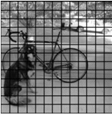

**Fig.1. Image divided into 13*13 grid cells.**

For each of these small grid cells, predict 5 bounding boxes. A bounding box is just a rectangle that has an object inside it. YOLO gives output as a number called as confidence score. This is output get from last layer of neural network. This output tells probability of an object available inside bounding box. From this score cannot tell which object is there in that box.

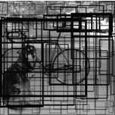

**Fig.2. Bounding Box (the higher the confidence score, the fatter the bounding box is drawn)**

For every box we got, there is a class predicted for every cell. We do image classification; we get a confidence score of all the available classes for that box. From this confidence score and bounding box, we finalize the score as final score. This final score tells us probability of bounding box containing a available object of a class. In below image on left hand side, the huge box is 60% sure that it contains the object of class “dog”

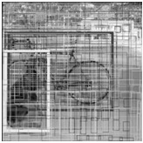

**Fig.3. Class prediction for bounding box**

Since we have divided image into 13 × 13, we got total 169 grid cells. All these grid cells cell is predicted for number of classes we have (5 classes). So, get 169×5= 845 different bounding boxes. To discard repeated predictions of same object,must discard some bounding boxes. Here we choose to discard boxes whose final score is less than 40% (we can change this threshold if we still get some repeated results). After removing class with final score less than threshold we get final prediction.

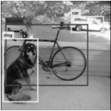

**Fig.5. Result of Object Detector (Dog, bicycle, car) with location**

845 bounding boxes are achieved. Out of that we consider only three bounding boxes because we got highest predictions for that box. Although we got 845 different predictions, but we got all predictions in one go. Our neural network made all predictions at same time. That is why YOLO makes faster predictions.

**DATASET-**

Collected different fruit images by scraping the internet. For Each class downloaded 100-110 images, “Download All Images” extension helped in downloading images forms a zip in the user’s PC. The images were in Various poses and different lighting conditions (i.e., in fluorescent, natural light, with or without sunshine) were preserved so that, can adapt and predict in any condition of the image. After the images have been downloaded with the help of labelimg software labelled all the images with respective to the class.

For each class created a dataset factors i.e., Glycemic Index, Glycemic Load, Dietary Fiber, Protein and Carbohydrates.

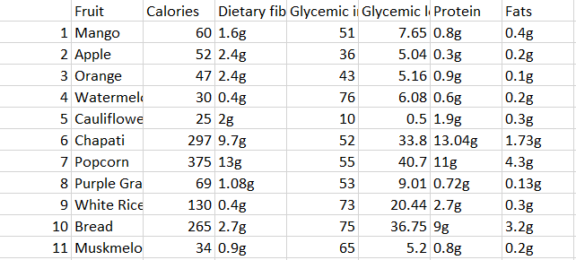

**Fig.6. Database in Xlsx Format**

The dataset has been collected for fruits and other food items. The glycemic index (GI) is a concept that ranks the glycemic potency of foods. It is calculated as the incremental area under the curve (iAUC) for blood glucose after consumption of a test food divided by the iAUC of a reference food containing the same amount of carbohydrate.

The Glycemic load (GL) is worked out by the following formula:

GL = GI x carbohydrate / 100

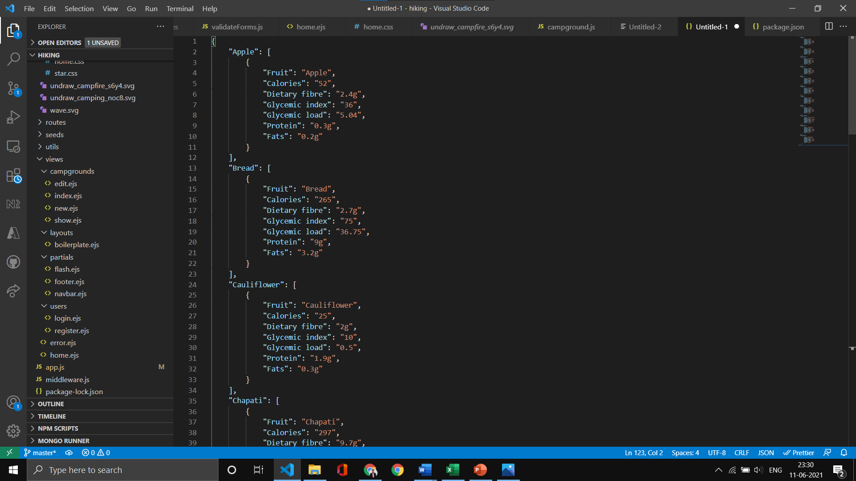

**Fig.6. Database in JSON Format**

Converted XLSX to JSON for compatibility of information into application.

**FRUIT DETECTION-**

The proposed mode has been integrated was Image processing model i.e., YOLO-Model with customized dataset for detecting different fruits and Information of the fruit.

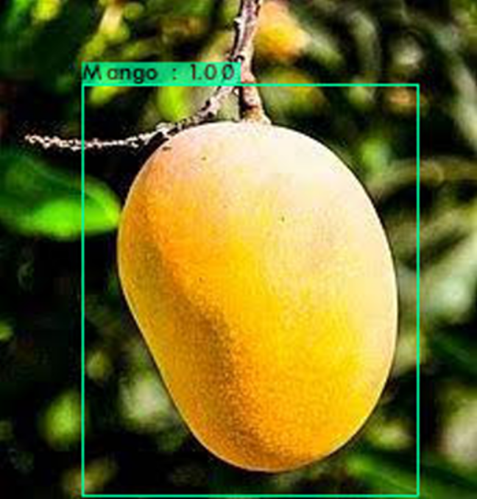

**Fig.7. Mango Precited with yolo model.**

The model has been converted to TensorFlow lite model. TensorFlow Lite is a set of tools that enables on-device machine learning by helping developers run their models on mobile, embedded, and IoT devices. TensorFlow lite the model after conversion gives Tflie file with the yolov4 information.

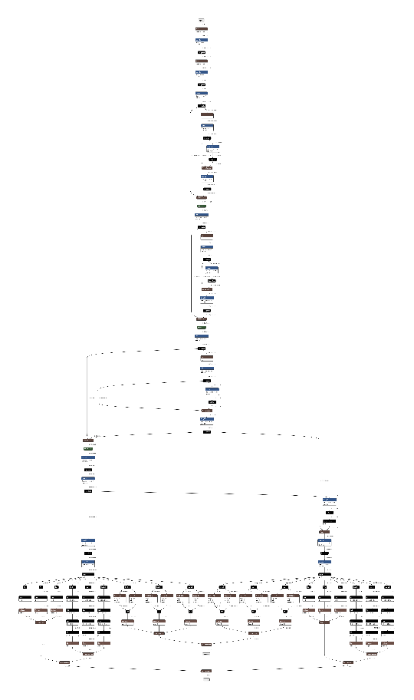

**Fig.8. Architecture of model from tflite file.**

After the tflite file has been converted from weights of yolov4 model. Integrated the tflite folder into a flutter application. All features of the model in the application with usefriendly and very interactive mobile UI. All features can be accessed with one click in the application. For integration with flutter need some external plugins such as:

**Camera:**

It is a Flutter plugin to access phone camera. As we are using flutter environment it will support both Android and IOS platform. It supports capturing images, capturing video, previewing the camera feed, and streaming image buffers to dart. This plugin for accessing mobile camera to capture real-time video stream to detect fruits and to check whether camera is working properly without any errors.

**tflite:**

A Flutter plugin for accessing Tensor Flow Lite API. This API supports many machines learning functions like image classification, object detection (YOLO and SSD), Pix2Pix, Deeplab and PoseNet on both platform Android and iOS devices. This plugin for integrating image processing model in our app to detect fruits.

# **CONCLUSION**

Tracking your food intake will give you insight into many aspects of your eating habits. The more specific and accurate you are with reporting, the more accurate your information will be. You may begin to see that you are missing entire food groups (i.e vegetables, dairy). Each food group provides us with nutrients crucial for maintaining health, so choose nutrient dense foods from all five food groups.

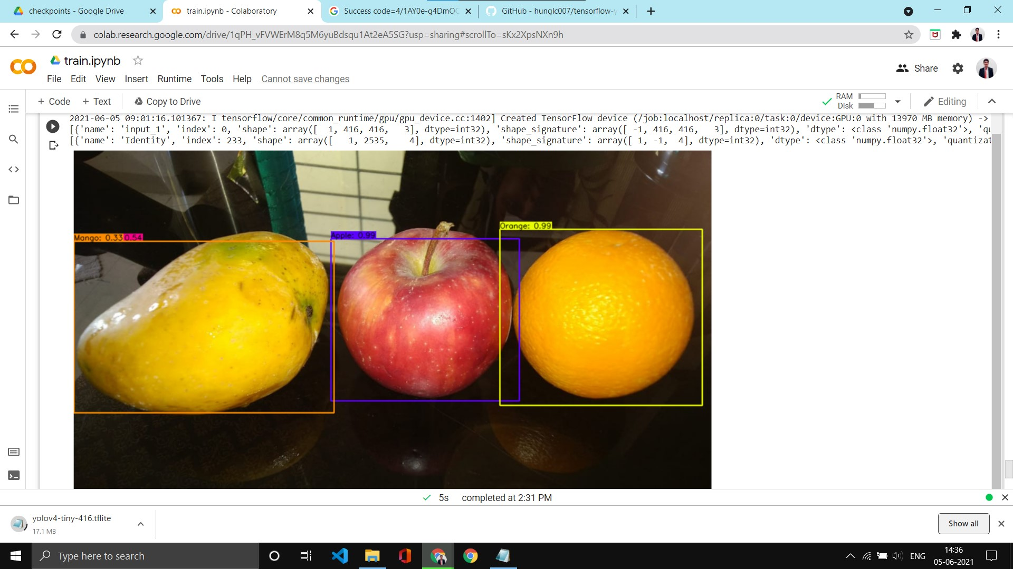

**Fig.9. Different Fruit Detection.**

The proposed model successfully recognizes 7 fruits and 4 different food items. Successfully deployed the model in Flutter software for android.

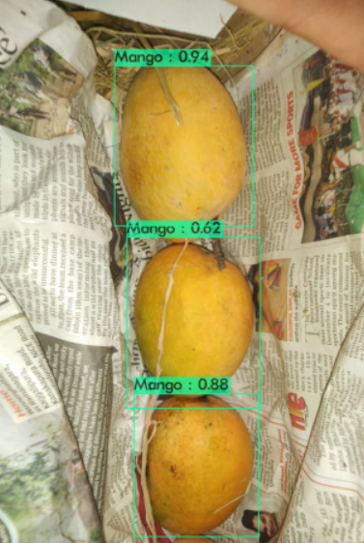

**Fig.10. Prediction Result.**

Fig.10 Predicted in 4.938000 milli-seconds.Mango: 94%

Mango: 62%, Mango: 88%.

The accuracy for the yolov4 tinny model CPU used T4. For tinny model can use for tiny_model, tiny_plus_model only T4 and K80 are allowed and for big model only P100, T4 and K80 are allowed. The proposed model achieved 89% accuracy.

# **FUTURE SCOPE**

Future work will focus on improving performance, continued progress on device compatibility. In the future, we can extend or expand the functionality of the model.More categories of food can be included: We plan to add to our dataset and that not only includes only raw vegetables and fruits but also traditional whole Indian meals. Personalize your monitoring: This includes a method to propose options or choices for next meals depending on your current intake of the day and your overall status of health and weight and your goal weight.Customer help to allow the users to give feedback and then to customize future meals accordingly.To include fitness plans which suggest necessary exercises to burn extra calories which again depends on the customer info considering factors like goal weight, current nutrient consumption, and age.

# **REFERENCES**

[1] Y. He, C. Xu, N. Khanna, C. Boushey, and E. Delp, “Analysis of food images: Features and classification,” in IEEE International Conference on Image Processing, 2014, pp. 2744-2748.

[2] D. T. Nguyen, Z. Zong, P. O. Ogunbona, Y. Probst, and W. Li, “Food image classification using local appearance and global

[3] T. Joutou, and K. Yanai, “A food image recognition system with Multiple Kernel Learning,” in 16th IEEE International Conference on Image Processing, 2009, pp. 285-288.

[4] H. Chen, J. Xu, G. Xiao, Q. Wu, and S. Zhang, “Fast auto-clean CNN model for online prediction of food materials,” Journal of Parallel and Distributed Computing. Kidlington, 2017, in press.

[5]Calorie Prediction from Food Images, Manal Chokr, Shady Elbassuoni

[6]Semi-Automated System for Predicting Calories in Photographs of Meals, Patrick McAlister, Huiru Zheng, Raymond Bond, Anne Moorhead

[7] Ashu Gulati, Rahul Samant, Tushar Tank (2020), Calorie Estimation System Using Object Detection by Deep Learning Technique, International Journal of Future Generation Communication and Networking Vol. 13, No. 2s, (2020), pp. 1532–1537